William Morgan

Professor Jones

12/10/2024

CSCI 209

HW04 Write up

In this program we implemented a “work” attribute to the program given in class. This work attribute lets us compare the time of different array sizes without increasing the array size. So, if we wanted to create an array of 100000 by 100000, but we do not have enough ram in our computer to create this array. We can then use an array of size 10000 by 10000 then declare work as 10. This would iterate through the 10000 by 10000 array 10 times. When we do this, we get the result of the time it would have taken to create the 100000 by 100000 array without using all that data.

The program first checks if all required arguments are met. Then if they are, we take in the values given by the user. The next thing is to start the create 1 time. We use the rows and columns given to create a regular 2d array. Then we calculate the time it took to do that. Next, we apply our work application to this array. We start off by nesting another loop around the given loops that is controlled by w. Then we populate the array with 42.5 and then after that we go back through the array and multiply each array value by i+j. Then we calculate the work time. 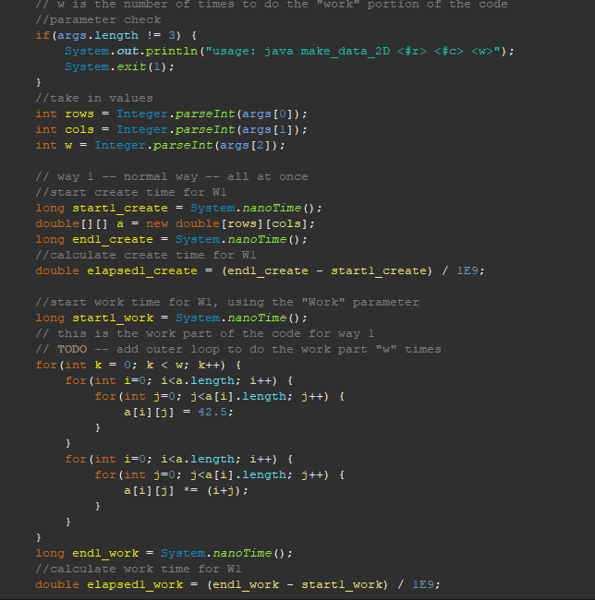

Next, we create the W2 array implementation. We do this by only initializing the array with rows and then tell each row the column size. Next, we calculate the time it took to initialize this array. The next piece of code is W2 work which is the same exact process as W1 work. After that, we calculate all the necessary times and print to the screen accordingly. 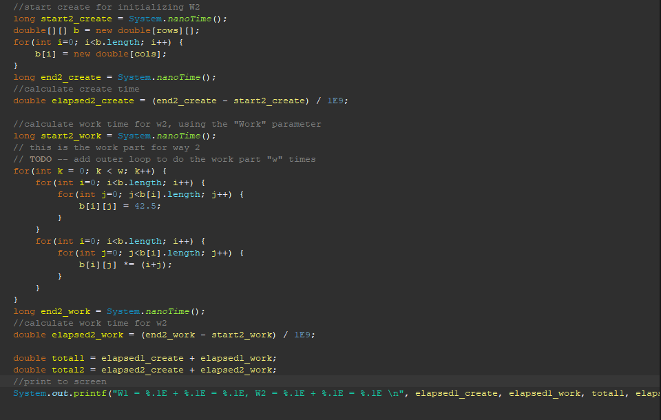

HW Screen shots

